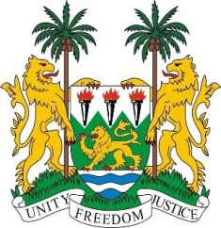
SIERRA LEONE
22nd Session of the UPR

LIBERIA

4 May 2015

Statement by Ambassador Yvette Stevens

Mr President,

Sierra Leone warmly welcomes the delegation of the Liberia and thanks them for their national report.

My delegation commends the efforts undertaken by the government to address the human rights situation in Liberia, as evidenced by the establishment of various National Action Plans since 2011, a Constitutional Review Committee and the Agenda for Transformation: Reconciliation Roadmap.

Like Sierra Leone, Liberia is keen to implement all its human rights obligations, but lacks the necessary resources to do so. Liberia would thus benefit from technical assistance in this regard.

As a sister State which is also recovering from the vicious outbreak of the Ebola Virus Disease, Sierra Leone is well aware of the significant socio-political challenges that Liberia faces with regards to rebuilding its national infrastructure which was either decimated or destroyed as a result of the disease.

Sierra Leone would like to make the following recommendations:

- Ratify the ICRMW, the ICPPED and the OP-ICESCR.
- Submit overdue reports to the relevant UN treaty bodies.
- Intensify efforts to seek necessary funding to address economic and social rights, in the wake of the Ebola crisis.

To conclude, Sierra Leone wishes Liberia a successful completion of this review process.

Thank you, Mr President.

